Design Patterns and Methodology

# SOLID design principals

Single responsibility principal   
Open/Closed principal  
Liskov substitution principal  
Interface segregation principal  
Dependency inversion principal

# Singleton Pattern

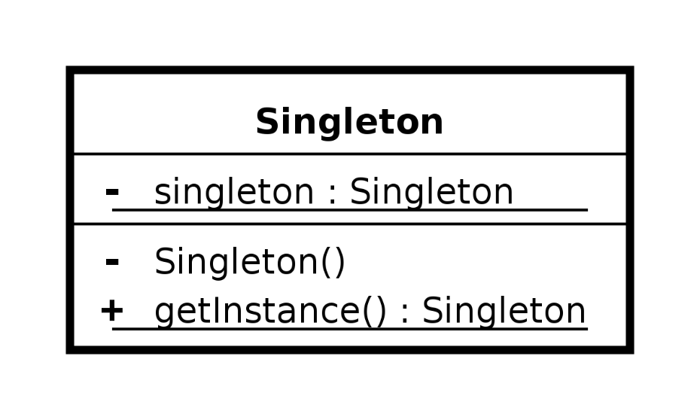

# Command Pattern

